**Assignment 16.1:**

**Problem Statement:**

Given a list of numbers - List[Int] (1, 2, 3, 4, 5, 6, 7, 8, 9, 10)

- find the sum of all numbers

- find the total elements in the list

- calculate the average of the numbers in the list

- find the sum of all the even numbers in the list

- find the total number of elements in the list divisible by both 5 and 3

**Solution:**

In Spark Shell, Load the list of data and create RDD for the list using spark context:





1. Find the sum of all numbers:



1. Find total elements in the list:



1. Calculate the average of the numbers in the list:



1. Find the sum of all the even numbers in the list:

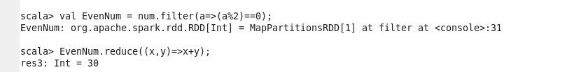

1. Find the total number of elements in the list divisible by both 5 and 3:

